**Ultimate AI Strategy Guide**

[[Babar Bhatti](https://medium.com/@thebabar?source=post_page-----9bfb5e9ecf4e--------------------------------)](https://medium.com/@thebabar?source=post_page-----9bfb5e9ecf4e--------------------------------)

[Babar Bhatti](https://medium.com/@thebabar?source=post_page-----9bfb5e9ecf4e--------------------------------)

[Apr 30, 2019·13 min read](https://towardsdatascience.com/ultimate-ai-strategy-guide-9bfb5e9ecf4e?source=post_page-----9bfb5e9ecf4e--------------------------------)

Strategy and AI are terms that are hard to pin down — they mean different things to different people. Combine AI and Strategy — 人工知能 战略 — and now you have a harder problem to tackle! The goal of this post is to bring in the best advice out there about AI strategy and add a practitioner’s point of view for a successfully crafting AI strategy.

This post is organized in three sections. Strategy and Planning, Building Blocks — Technology, People/Culture and Roadmap for launching and sustaining AI.

In last couple of years it has become crystal clear that AI will be a major factor for business. Gartner included AI in its top 10 strategic technology trends for 2019. Most companies are keenly aware that they should have at least have an AI strategy. If nothing else, the propensity to follow AI rivals is high [1].

*The competitive intensity surrounding the technology suggests that a wait-and-see strategy could be a costly mistake. To get a share of the global profit pool of $1 trillion that AI will produce by 2030, the McKinsey Global Institute says companies should begin adopting it at scale within the next three years.*

Enterprises, however, are struggling to get AI strategy right, very much like they had challenges with e-commerce adoption in late 90s. Many things can go wrong with nascent technology adoption — Choosing or spending on the wrong initiatives, not finding the right talent and choosing the wrong direction.

Fundamentals of Strategy and AI

First, let’s be crystal clear on the definition of strategy. I love the way Rumelt [2] defines strategy and will follow his no BS, practical approach. In “Good Strategy, Bad Strategy” Rumelt writes that there are three key parts to a strategy that make up the *Strategy Kernel*.

1. Diagnosis — what is wrong, why? link tech with biz strategy
2. Guiding Policy — foundation, governance, culture, ethics
3. Coherent Actions — resource allocation, implementation, buy/build decisions, process orchestration, talent development/hiring/retention, culture and change management

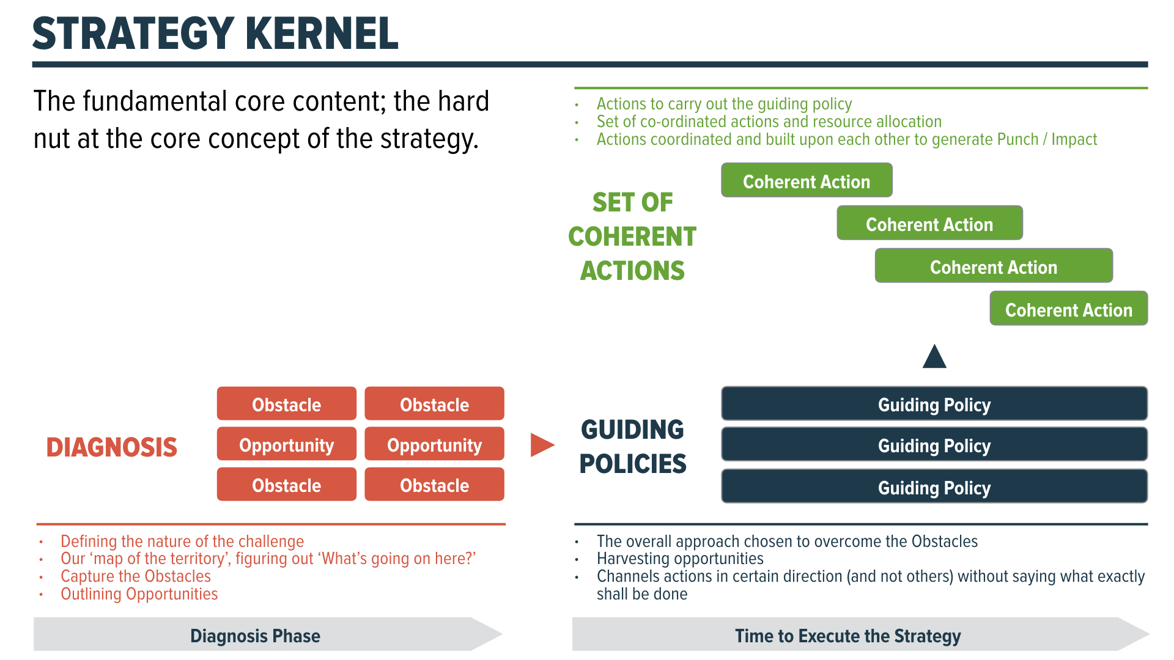

Second, let’s define AI: broadly speaking AI encompasses the techniques used to teach computers to learn, reason, perceive, infer, communicate and make decisions similar to or better than humans. AI areas includes intelligent automation, machine learning (classical machine learning and modern deep learning aka deep neural networks) and robotics. Self-driving cars combine a lot of what is symbolic of modern AI.

Here’s my one-liner AI for business equation.

*A****I = data+algorithms+compute → business problem → results***

The hard problem is to craft an AI strategy that works for your specific business context — i.e it considers all the external factors as well as internal factors. Andrew Ng recommends “becoming a leading AI company in your industry sector, where developing unique AI capabilities will allow you to gain a competitive advantage.”

How AI affects your company’s strategy will be industry- and situation-specific, Andrew adds.

Many experts note that you can’t start with AI strategy as a first step because you need to develop understanding of AI and that requires experimentation under uncertainty. This has the benefit of learning through the so-called Virtuous Cycle of AI.



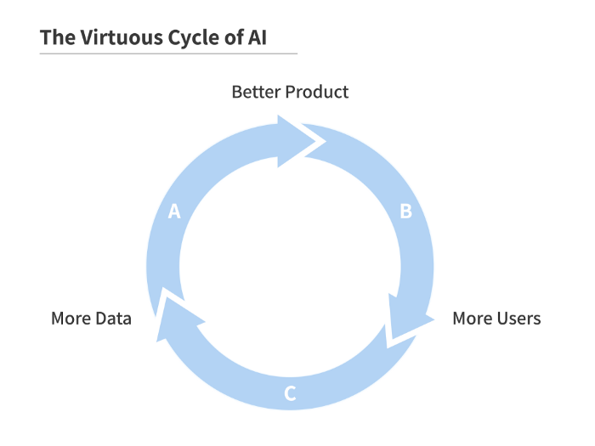

From Andrew Ng — AI Transformation Playbook [4] — [Link](https://landing.ai/ai-transformation-playbook/)

Just like the architecture of any strong building requires, you need to start with the ground conditions and ensure that you build a strong foundation. Otherwise whatever superstructure you build will suffer from costly problems in future.

The next sections talk more about how to build a digital foundation with data, algorithms and computing infrastructure that is appropriate for your situation. You need people with diverse backgrounds, education and skills — for instance you need people with data expertise and machine learning knowledge but also those who are good at bridging business and technical issues, also called “translators.” And you need strong processes.

Be realistic about benefits as well as limitations of AI. There are good use cases for AI and there are use cases that could get you on a rabbit trail with no clear pathway to value. There’s a gradual path that a company could take such as trying out Robotic Process Automation before engaging in more complex projects.

“AI will improve products and processes and make decisions better informed — important but largely invisible tasks.” — Thomas Davenport [10]

As Rumelt points out, it is helpful to look at examples of bad strategy so you can avoid it. Here are a few commonly found elements of bad strategy.

* Mistaking goals for strategy — don’t just state that you want AI leadership, create conditions to get you there
* Fuzzy Strategic Objectives — a long list of things to do without a clear plan on how to get there, lack of focus of energy and resources
* Lack of Coordinated Actions — duplication of efforts, politics of ownership, decisions that send mixed signals, lack of fundamental understanding of AI by senior executives
* Inability to Choose and Prioritize— which projects are good candidates for AI? what management and organizational structure should we choose?

Understand the Building Blocks — Technology

Remember, Strategy is all about taking action to overcome obstacle or seize opportunities [2]. Any AI effort will rely on three main building blocks: data, infrastructure and talent.

* **Data** is the essential element of today’s AI that drives insights — more than the algorithm itself in many cases. It requires significant effort and investment to get your data foundation right. Improving data quality and governing data is a complicated and long-term effort. Data ownership is a vexing problem for managers across all industries. Some data is proprietary, other data is fragmented across data sources, requiring consolidation and agreements with multiple other organizations in order to get more complete information for training AI systems.

*Linking data across customer segments and channels, rather than allowing the data to languish in silos, is especially important to create value. -McKinsey [15]*

* **Computing Infrastructure,** including software and hardware, must be in place to run machine learning models effectively. ML needs specialized hardware (GPU, FPGA, or ASIC) — whether in the cloud or on-premise (due to regulation or other business reasons.)
* **AI Talent** is vital in making effective use of machine learning. While not every company will seek to build an internal AI organization, having access to experienced data scientists, data engineers, data product managers and AI dev ops specialists is key to driving value from AI and scaling it to profitability.

Andrew Ng [4] advises that for a company to be great at AI, it must have:

***Resources to systematically execute****on multiple valuable AI projects — either outsourced and/or in-house technology and talent.*

***Sufficient understanding of AI****: There should be general understanding of AI, with appropriate processes in place to systematically identify and select valuable AI projects to work on.*

***Strategic direction****: Is the company’s strategy broadly****aligned****to succeed in an AI-powered future?*

Building Blocks — People and Culture

You may think that technology is the key to AI strategy but people and culture are as crucial to the success of your AI strategy as the technology. In a recent survey report by O’Reilly it was evident that culture is the main challenge for AI adoption. For one, AI is something that requires different groups to work together and if the culture of cooperation does not exist, AI initiatives will suffer.

AI also means change and disruption to people’s jobs and processes. Automation that accompanies AI can replace many jobs and force others to learn new skills. It is a blackbox most of the time and for some scenarios its value is unproven. No wonder many in the workforce worry about AI and feel out of their comfort zone as AI is being implemented.

Algorithms require new governance models. As with any cultural change, tread lightly and carefully before making big changes.

According to the survey results from O’Reilly Media, wider adoption of AI across organizations is being held back by a corporate culture that doesn’t recognize the need, a lack of data and a shortage of talent.

The bottlenecks.*A large number of respondents, 23%, said company culture was the major impediment to AI adoption, 19% said the biggest issues were a lack of data or data quality, 18% said it was a lack of skilled people and difficulty hiring talent, 17% said it was difficulties in identifying appropriate business use cases and 8% said it was technical infrastructure challenges.*

Talent hiring and management remains a key factor. Before you start on the hiring track, define what would the right team look like? You want people with depth and variety of skills, experience and have diversity. As pointed out in this post [12], the right team should include domain experts and social scientists who can provide complementary viewpoints and support the technology team. Don’t get obsessed with hiring the rock stars of AI without creating the conditions of success.

There’s more to AI technology management, as mentioned in [6].

*The management of AI technology also involves new leadership skills, including those required to implement modern processes embedded with AI. Companies that are successfully embracing AI are committed to transformation programs, with top management embracing the change and cross- functional management teams ready to redefine their processes and activities.*

Create and encourage means of tracking and revealing AI decisions — ideally using action audit trails and features that visualize or explain results. Involve designers and UI / UX experts. Make sure non-technical managers understand the explanations well.

Of course, good old communication or lack thereof is a major cause of problems [9].

*AI strategies’ fail because AI is a means, not an end. “Do you have an AI strategy?” makes as much sense as asking, “Do we have an Excel strategy?” But for companies to get past the hype and focus on the real potential that AI offers, they’ll have to start with how they communicate.*

**Gaps to Look Out For**

Watch for 3 critical gaps: business-IT gaps, data-analytics gaps and veteran-rookie gaps (more on people and culture part later in the post). Building trust and detection and removal of bias in AI remains one of the biggest challenge to AI adoption.

As mentioned by Moldoveanu in this HBR article [9], there are very different styles of working between technologists and business folks.

*Developers want clear, precise instructions that are easily translatable into code or pseudo-code. Business development executives provide them with stories and anecdotes.*

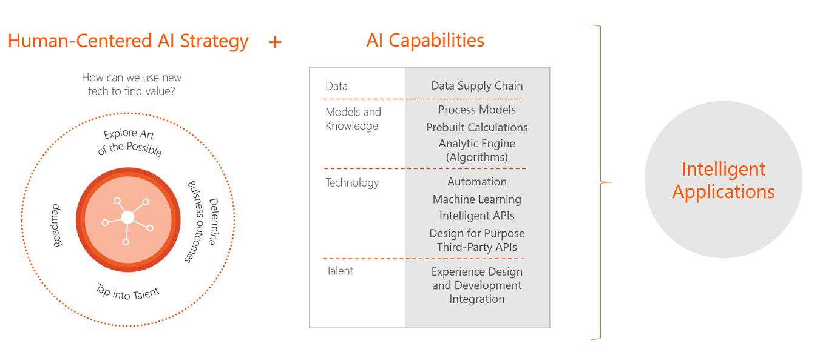

Credit: [Avanade.com](https://www.avanade.com/fr-be/solutions/analytics-and-ai/artificial-intelligence)

There’s also a risk factor that must not be ignored. Your AI strategy could backfire if it has negative consequences or regulation issues. Take a look at [13] to learn more and and [14] on how to mitigate this risk.

Ethics, fairness and inclusiveness need to be considered carefully. In a [Washington Post column](https://www.washingtonpost.com/opinions/2019/01/23/can-we-make-artificial-intelligence-ethical/) Blackstone Group Chief Executive Officer Stephen Schwarzman recommends an ethics-driven approach to AI that tells consumer when AI is being used, avoids bias, addresses privacy concerns and looks to develop opportunities for workers displaced by technology.

These are hot topics with many different perspectives and a detailed discussion is beyond the scope of this post — see my primer on fair and responsible AI [11] for a summary of key issues.

Roadmap for Launching and Sustaining AI Initiatives

The sections above talked about the technology, people, culture and ethics. Now let’s address some of the practical ways to deploy and scale AI initiatives and the common challenges faced by enterprises. The key success factors for successful execution of a strategy include effective processes and governance, managing resources and navigating around risks. This section includes a collection of tools and resources to keep you on the right path of AI adoption.

* Common Challenges
* Framework
* Recommendations
* Checklist
* Digital Maturity Assessment

**Challenges — Don’t Underestimate the Challenges and Effort Needed for AI Success**

With so much buzz and hype going around it could be tempting for companies to jump in, thinking that AI could start producing favorable results quickly. Studies show that organizations tend to underestimate how long it will take to overcome complexities and get AI off the ground.

Experimentation and learning with AI can take much longer than other digital initiatives, with a higher variability of success and failure.

*According to results from a 2017 Annual Enterprise Survey, 58% of respondents in companies currently piloting AI projects say it took two or more years to reach the piloting phase, and only 28% of respondents reported getting past the planning stage in the first year.*

Some organizations get lost in the many different prototypes and POCs and fail to scale — you don’t often hear about the failed projects or initiatives that start with lots of buzz but then fizzle out because of quality of results or lack of clear ROI. Larger organizations have found success with creating centers of excellence and organizational structures that provide oversight but allow for autonomy to business units.

Get a dose of reality by talking to your peers and listening to practitioners, not just analysts and authors of books who tend to highlight success stories disproportionately.

Trust is a major factor. How can you convince non-technical teams that the AI solutions are reliable and dependable? Deep learning is a hot area but it is notoriously hard to interpret how it makes decisions. It requires careful planning and communication to achieve this.

Your AI strategy could backfire if it triggers negative consequences or causes regulation issues. Take a look at [13] to learn more and and [14] on how to mitigate this risk.

**Strategic Planning for AI**

This simple diagram captures the key elements of a strategic plan for AI.



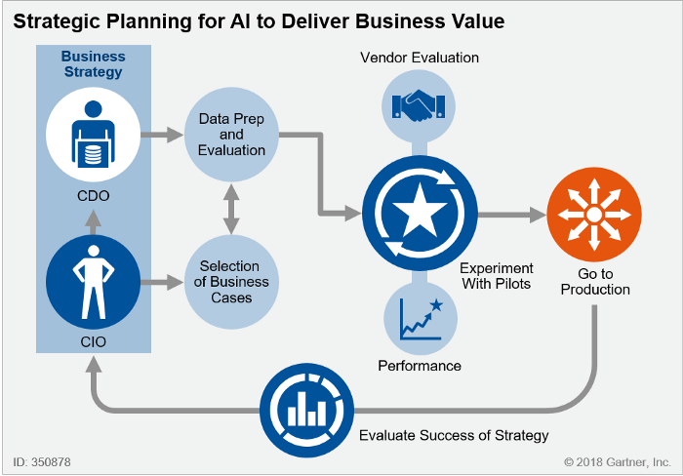

Credit: Gartner, Inc. [5]

**Framework for AI**

It is best to think of AI strategy in terms of business outcomes and then work back towards common enterprise functions and solution areas. For example, if you have a good use case for chatbots then the technology can be used by more than one group.

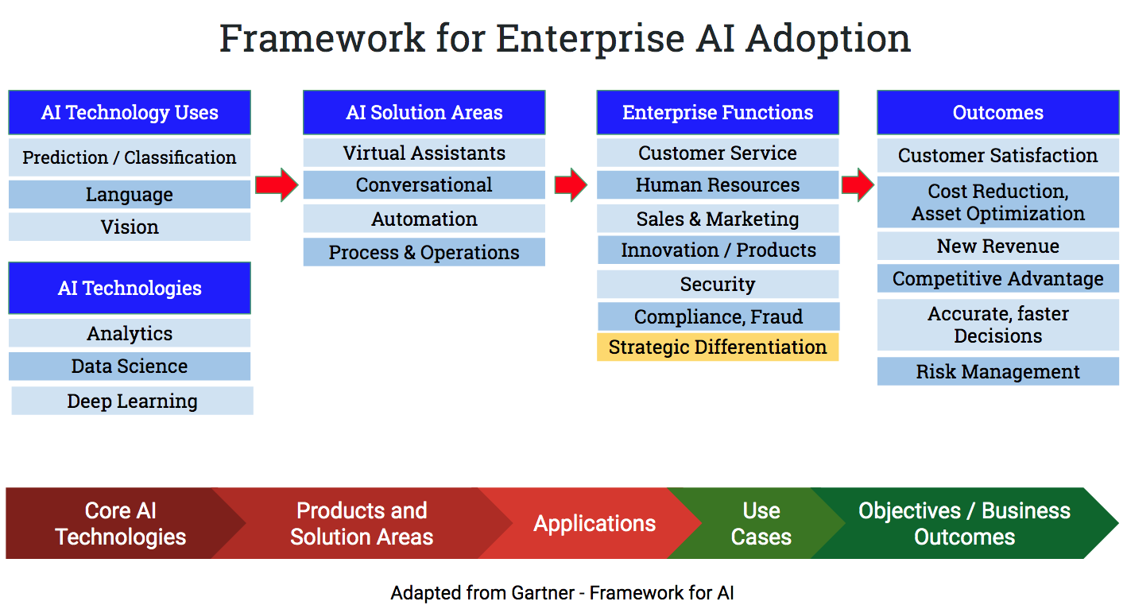

Managing AI teams

Many models exist — centralized and distributed models have their pros and cons.

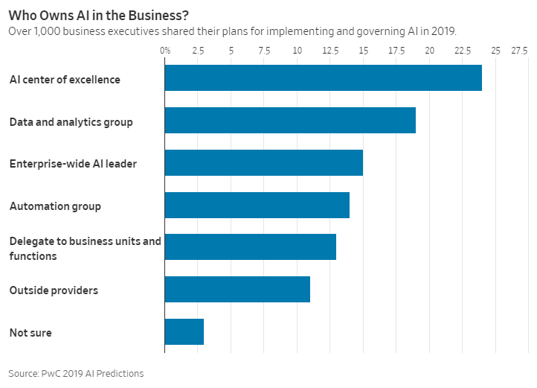

**AI Strategy Recommendations**

1. **Digital Maturity**: Where do you stand on the digital maturity curve? How can you accelerate it so that you can accelerate the pace of AI capabilities?
2. **Evaluate Business Potential:** What is the right use case? is there enough value?Think deeply about use cases, evaluate multiple scenarios
3. **Gradual Approach**: Take a staged approach to the AI journey. In the short-term, focus on a use cases with proven technology; medium-term, experiment with technologies to assess their value; and long-term, work with bleeding-edge technology that could give the business a first-mover advantage. Remember, AI technologies are not mature, don’t expect ROI right away
4. **Leadership**: Resist the temptation to put technology teams solely in charge of AI initiatives. Developments should be co-led by business and technology leaders [Mckinsey]
5. **Make vs Buy**: Should you build, buy or outsource? Do you have the talent needed to make sense of the various new approaches? As with any new technology with hype around it, there’s no shortage of newly minted solutions and consultants. Develop core leadership and knowledge throughout your organization while getting help from outside experts as needed

**Checklist for AI Strategy**

Here’s a simple checklist by Gartner on AI Adoption.



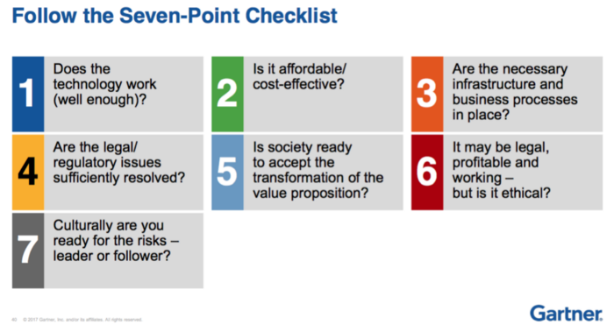

Credit: Gartner, Inc. [5]

**Digital Maturity Assessment for AI**

Even in industries with extensive histories of integrating new technologies and managing data, barriers to AI adoption can be difficult to overcome. AI requires even more radical thinking, as it affects knowledge- and judgment-based professions. This article from MIT Sloan Review asks: What prevents organizations from adopting AI?

**[Reshaping Business With Artificial Intelligence](https://sloanreview.mit.edu/projects/reshaping-business-with-artificial-intelligence/" \t "_blank)**

[About the Authors: Sam Ransbotham is an associate professor in the information systems department at the Carroll School…](https://sloanreview.mit.edu/projects/reshaping-business-with-artificial-intelligence/" \t "_blank)

[sloanreview.mit.edu](https://sloanreview.mit.edu/projects/reshaping-business-with-artificial-intelligence/" \t "_blank)

It defines four distinct organizational maturity clusters: Pioneers, Investigators, Experimenters, and Passives

* **Pioneers (19%):** Organizations that both understand and have adopted AI. These organizations are on the leading edge of incorporating AI into both their organization’s offerings and internal processes.
* **Investigators (32%):** Organizations that understand AI but are not deploying it beyond the pilot stage. Their investigation into what AI may offer emphasizes looking before leaping.
* **Experimenters (13%):** Organizations that are piloting or adopting AI without deep understanding. These organizations are learning by doing.
* **Passives (36%):** Organizations with no adoption or much understanding of AI. They have not identified solid business cases that meet their investment criteria. Leadership may not be on board.

Conclusion

This post has presented many facets of AI strategy. At the end what will matter most are vision and leadership, openness and ability to change, long-term thinking, close alignment between business and technology strategy, and a culture that overcomes hurdles ad adapts to new technology.

References:

1. Jacques Bughin**.**Wait-and-See Could Be a Costly AI Strategy. MIT Sloan Review, 2018. <https://sloanreview.mit.edu/article/wait-and-see-could-be-a-costly-ai-strategy/>
2. Richard Rumelt, Good Strategy, Bad Strategy. Crown Publishing, 2011.(Also see this r[elated post](https://medium.com/@maa1/book-review-good-strategy-bad-strategy-1e7eace07dd1) about the book.)
3. AI Business School by Microsoft. Online at <https://www.microsoft.com/en-us/ai/ai-business-school>
4. Andrew Ng. AI Transformation Playbook (available from <https://landing.ai/ai-transformation-playbook/>), Landing AI. 2019.
5. Bern Elliott, A Framework for Applying AI in the Enterprise (webinar presentation), Gartner.com, 2018.
6. Jacques Bughin and Eric Hazan. Five management strategies for getting the most from AI. McKinsey.com and MIT Sloan Management Review, 2017. <https://www.mckinsey.com/mgi/overview/in-the-news/five-management-strategies-for-getting-the-most-from-ai>
7. Anand Rao, A Strategist’s Guide to Artificial Intelligence. PWC Strategy+Business, 2017.
8. Whit Andrews, Editor. Build the AI Business Case. A CIO’s guide to building the strategy and business case to implement AI in the enterprise. Gartner.com. 2018.
9. Mihnea Moldoveanu. Why AI Underperforms and What Companies Can Do About It. HBR, 2019. [https://hbr.org/2019/03/why-ai-underperforms-and-what-companies-can-do-about-it?](https://hbr.org/2019/03/why-ai-underperforms-and-what-companies-can-do-about-it?autocomplete=true)
10. Thomas Davenport. The AI Advantage: How to Put the Artificial Intelligence Revolution to Work. MIT Press. 2018.
11. Babar Bhatti. Primer on Fair and Responsible ML and AI. <https://towardsdatascience.com/ai-policy-making-part-4-a-primer-on-fair-and-responsible-ml-and-ai-28f52b32190f>
12. [Cassie Kozyrkov](https://hackernoon.com/@kozyrkov?source=user_popover). Why businesses fail at machine learning. <https://hackernoon.com/why-businesses-fail-at-machine-learning-fbff41c4d5db>
13. Michael Spencer. The Dangers of Artificial Intelligence in 2019. <https://medium.com/futuresin/the-dangers-of-artificial-intelligence-in-2019-19e14fa45aa4>
14. Bernhard Babel, Kevin Buehler, Adam Pivonka, Bryan Richardson, and Derek Waldro. Derisking machine learning and artificial intelligence. McKinsey, 2019. <https://www.mckinsey.com/business-functions/risk/our-insights/derisking-machine-learning-and-artificial-intelligence>
15. [Michael Chui](https://www.mckinsey.com/our-people/michael-chui), [James Manyika](https://www.mckinsey.com/our-people/james-manyika), Mehdi Miremadi, [Nicolaus Henke](https://www.mckinsey.com/our-people/nicolaus-henke), Rita Chung, Pieter Nel, and Sankalp Malhotra. McKinsey, 2018. <https://www.mckinsey.com/featured-insights/artificial-intelligence/notes-from-the-ai-frontier-applications-and-value-of-deep-learning>